Tollis Campaign

Background

Positioned on the galactic equator in the middle of the “east central” jump route between the stellar systems controlled by the Galactic Union and the Stellar Confederation, the Tollis system was an obvious target for both stellar alliances. Years of secret negotiations led to the alignment of the western city states with the Galactic Union, and the eastern city states with the Stellar Confederacy. These alignments led to increasing boldness and hostility between the rival factions on Tollis and a tightening of their relationships with the stellar alliances. The inevitable outcome was open conflict between the east and west and invitations to the two stellar alliances to intervene. Fully prepared for this eventuality, the stellar alliances began to pour troops into Tollis to back up their respective allies.

Both alliances landed their first troops on the same day – the Stellar Confederacy in Dekalb in the northeast and Lenox in the southeast, and the Galactic Union at Woodridge in the northwest and in the central west in the open plains southwest of Lyle. These forces immediately pushed forward followed by a steady stream of new units as the two stellar alliances moved to deploy their forces on their respective sides of the border. Both sides were determined to give battle on an almost continuous front. After six days the opposing forces were mostly deployed.

Unknown to the city states of Tollis the goal of the two stellar alliances was not to make significant territorial gains for any of their client city states, but to gain total control over the planet and its adjacent jump point. Eventually the Tollis city states would see the need for ceasefire negotiations, but by that time their roles in the conflict had been minimized and their politicians and diplomats had little bargaining power. Tollis had become another pawn in an interstellar power struggle.

Day Eight – Sector 7.8

On this day most of the battle groups on both sides were exhausted after several days of continuous movement followed by hard-fought battles. For the most part the opposing battlegroups rested, refitted and resupplied to the best of their abilities.

The one exception was in Sector 7.8, where the Zokar 609th Battlegroup (of the Stellar Confederacy) advanced into defensive positions held by the Gavilan 120th Battlegroup (of the Galactic Union). The defenders were well dug-in, with extensive trenches and fieldworks sheltered in wooded areas, with support from autocannon, plasma rifle and rocket artillery turrets. The Gavilan forces fielded a powerful communication jamming system, which prevented enemy communications for roughly 80% of the battle. In addition, the defenders were supported by effective close air support, which was very destructive in the early phases of the battle, until it was intercepted and countered by the Zokaran combat air patrols.

Most of the battle was dominated by long-range duels between the heavy armored vehicles of the two battlegroups. Both sides scored some notable successes, but the Zokaran armor gradually gained an advantage that allowed their infantry and wardrone forces to advance and reduce the defenders. In particular, on the Zokaran right flank strong forces of Saurid jet-pack troopers and Bearcat wardrones surged forward across relatively open ground after the forces opposing them had been heavily reduced by repeated artillery strikes. With losses mounting and no prospect of gaining an advantage that would turn the battle around, Gavilan Command ordered a retreat.

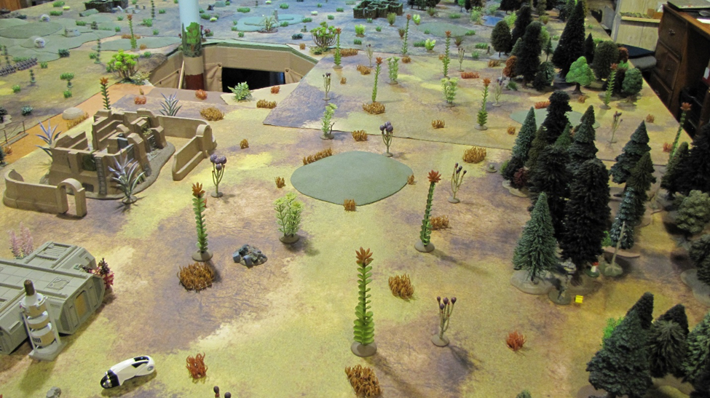
The battlefield, looking north across the eastern half of the field.

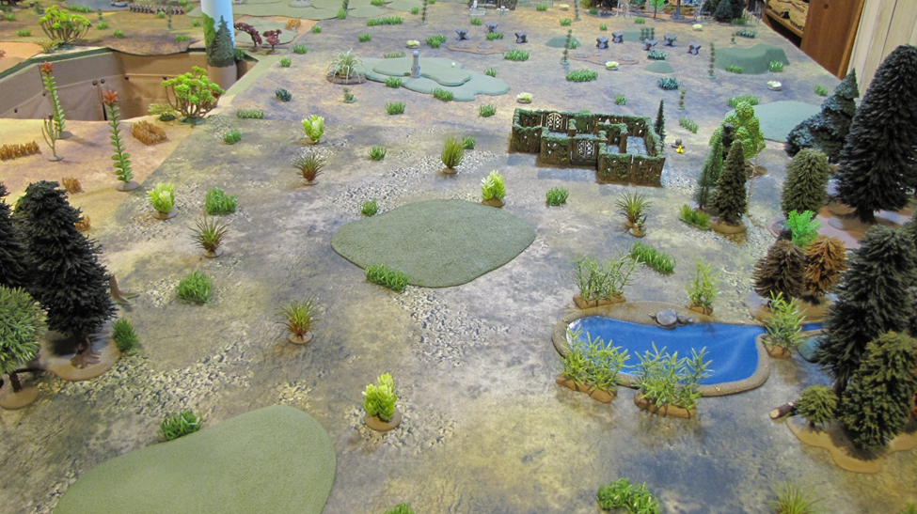
The battlefield, looking south across the western half of the field.

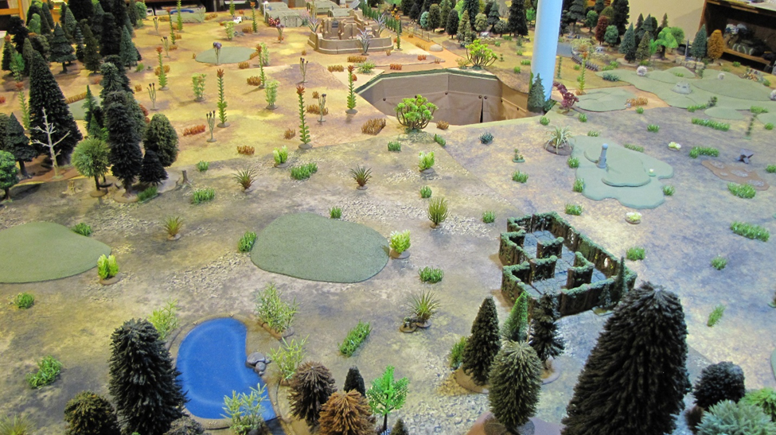
Looking east from the northwestern corner of the field.

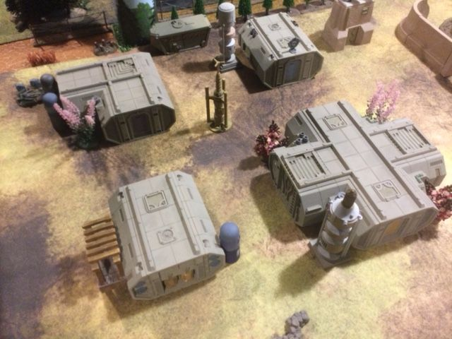
An abandoned science station stood near the southern edge of the field. It was not included in the Gavilan defenses, but a squad and warbot would advance into it once enemy activity was detected.

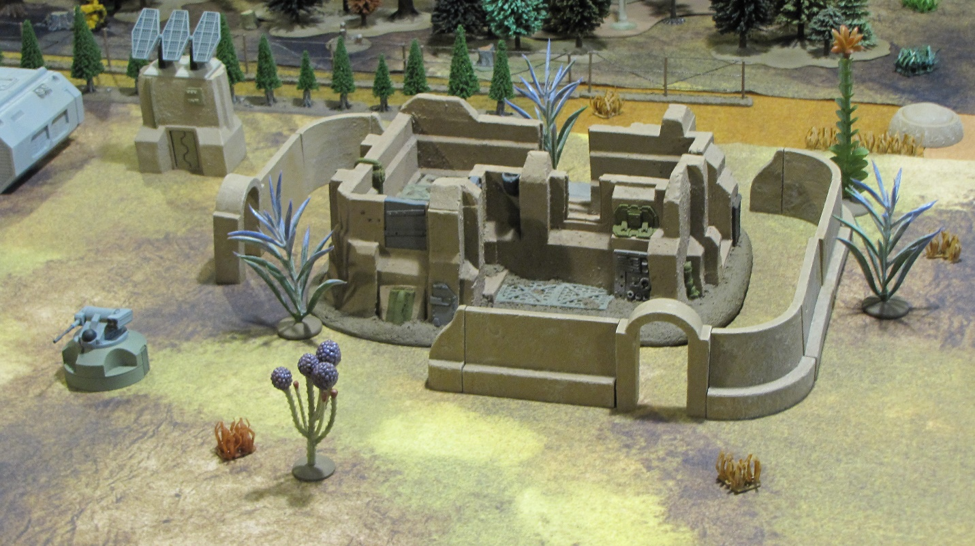
A building complex known as the “old fort” stood just north of the science station. It was not included in the defenses. Before the battle, the Corvus SM-32A 25mm turret was moved back into the woods to provide a more concealed position for flanking fire.

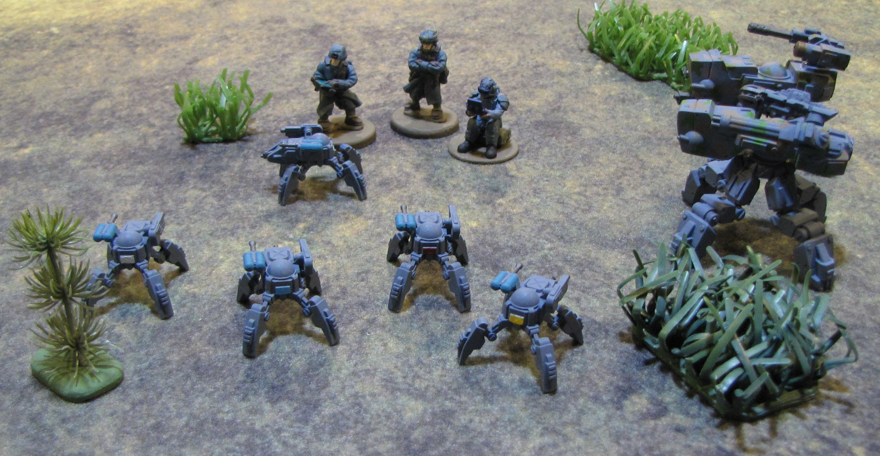
Before the battle, officers and technicians of the Gavilan 83rd Rangers test the performance of Creeper G-226 light warbots and G-228 heavy warbots.

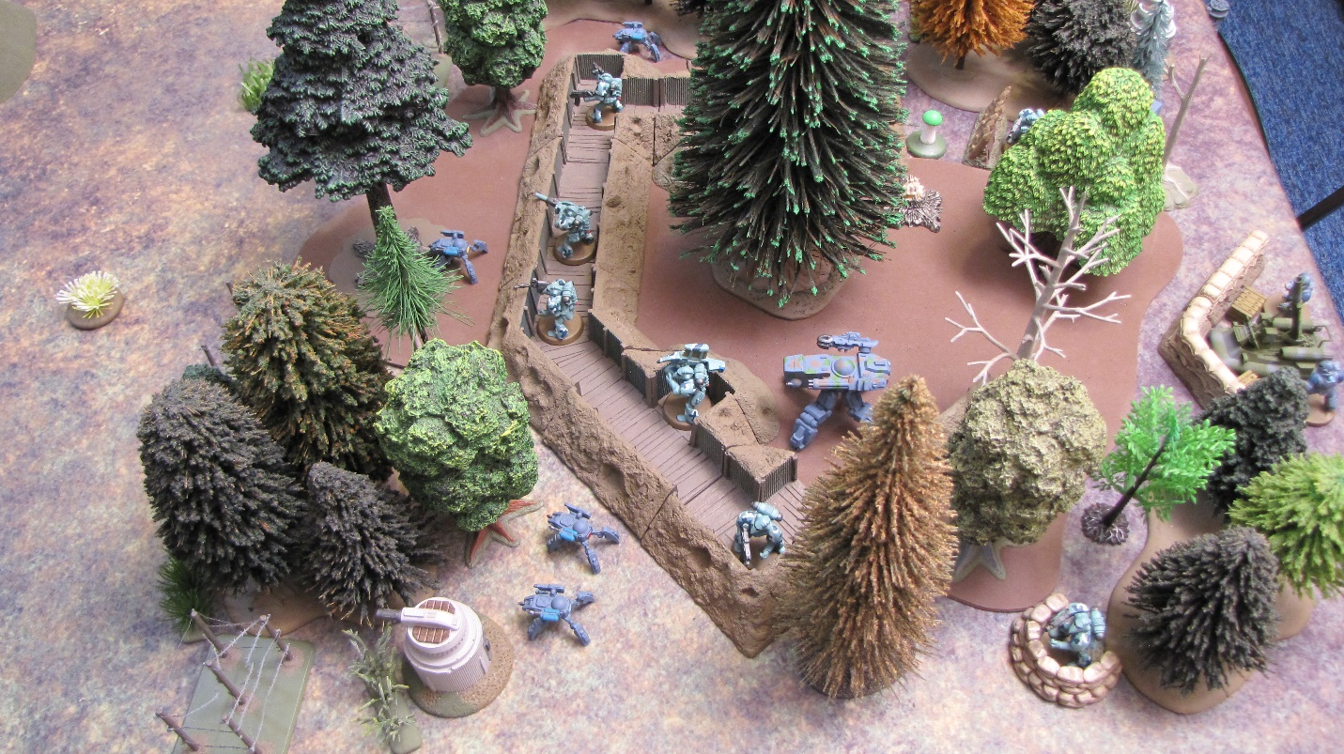
The Creeper warbots were stationed on the Gavilan left flank with the 3rd Squad of the 16th Chargers.

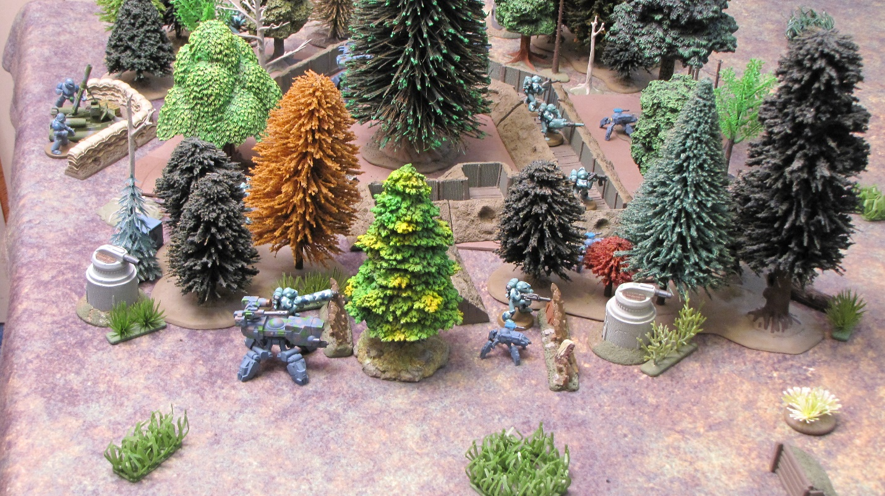
This position was bolstered with three Firespout LU-103 turrets (medium plasma rifle) and a mortar team with an Arrow G-19B grav 90mm mortar.

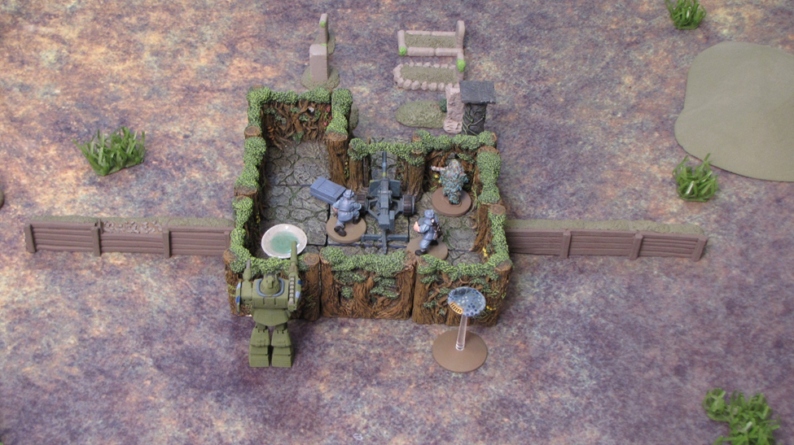
Moving south, a small memorial garden was occupied by a 50mm hypervelocity cannon team, a sniper, a Discus recon drone and a Gladiator medium wardrone.

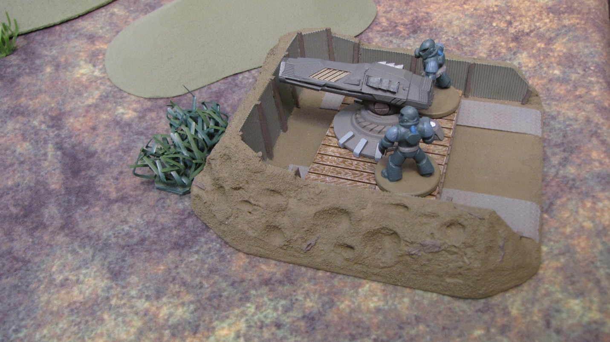
Farther south was a Sunfire LU-307 medium fusion cannon, . . .

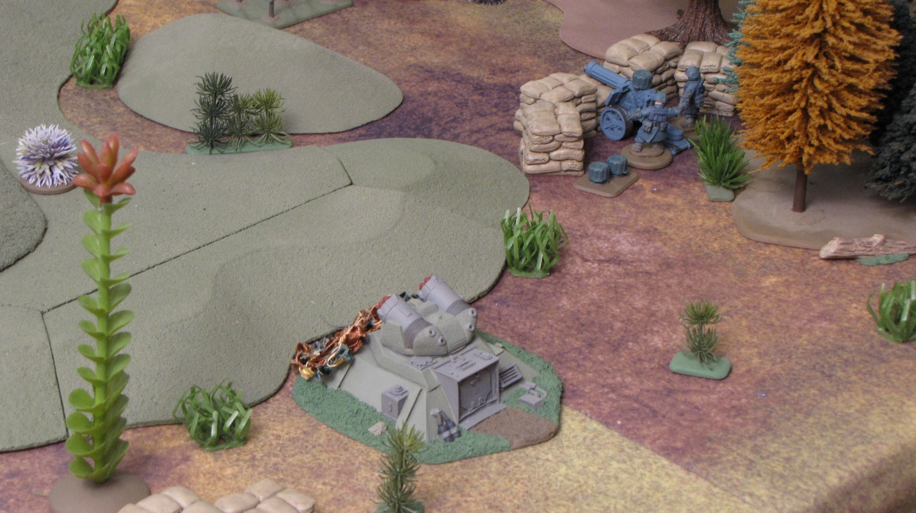
. . . a Firestorm HA-113C medium artillery strongpoint and a weapon team of the 83rd Rangers with an ultra-machinegun. The woods in the Gavilan center were held by entrenched infantry squads of the 83rd Rangers supported by two Corvus turrets and two wardrones. No photos of these forces were recovered.

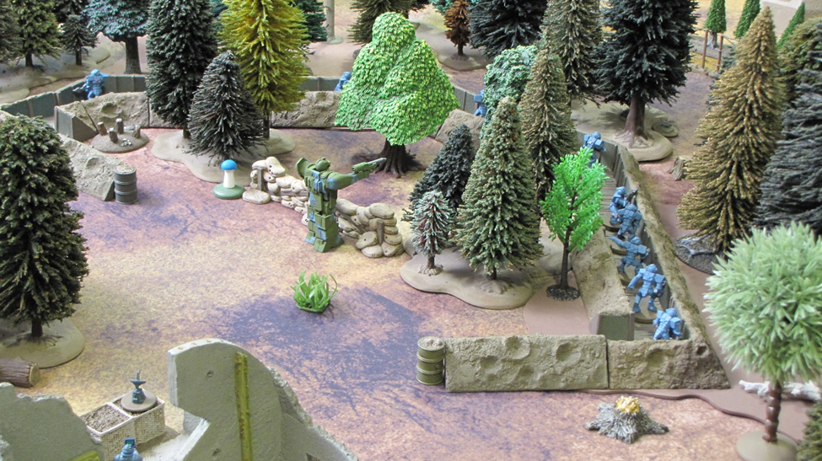
Farther south, the 114th Felid Strikers were entrenched in the woods to the west of the “old fort” and science station. A Guardian G-170 medium wardrone stands ready to their rear.

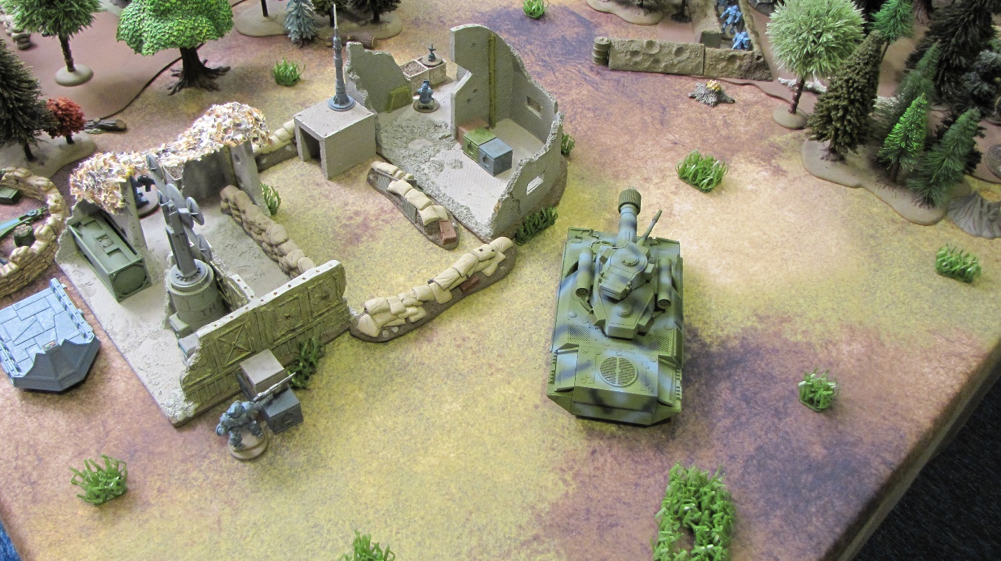
Behind the 114th, on the far right flank stood the Gavilan HQ with its anti-communication ECM array and a Vanguard G-93 grav tank. The ECM array would effectively cut-off Zokaran communications for the first and last hours of the battle, leaving only one-half hour in the middle of the battle where the Zokarans could provide targets to their artillery and communicate with their overhead drone.

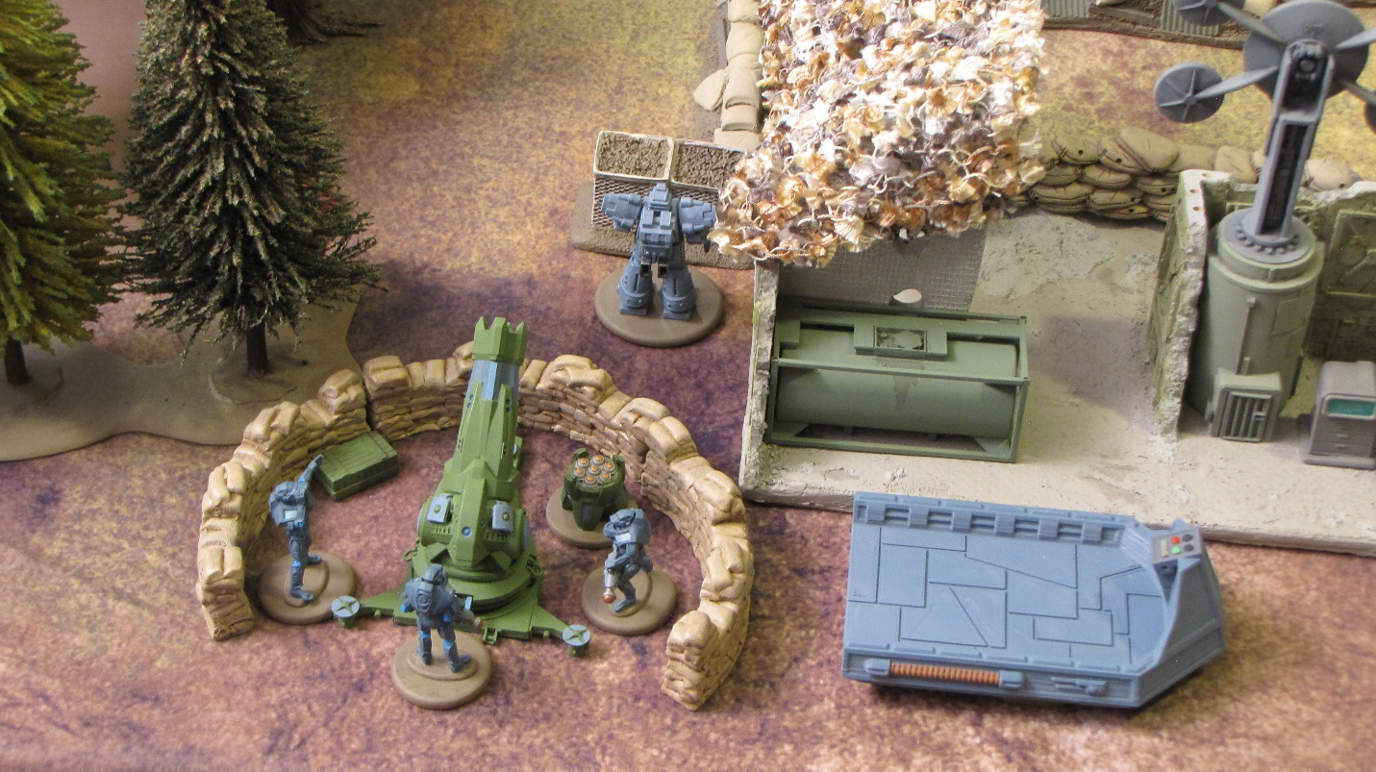
A heavy plasma bombard and a Bandit G-138 light wardrone stand by. The Mule 300 is a military grav lifter that is employed by every stellar nation.

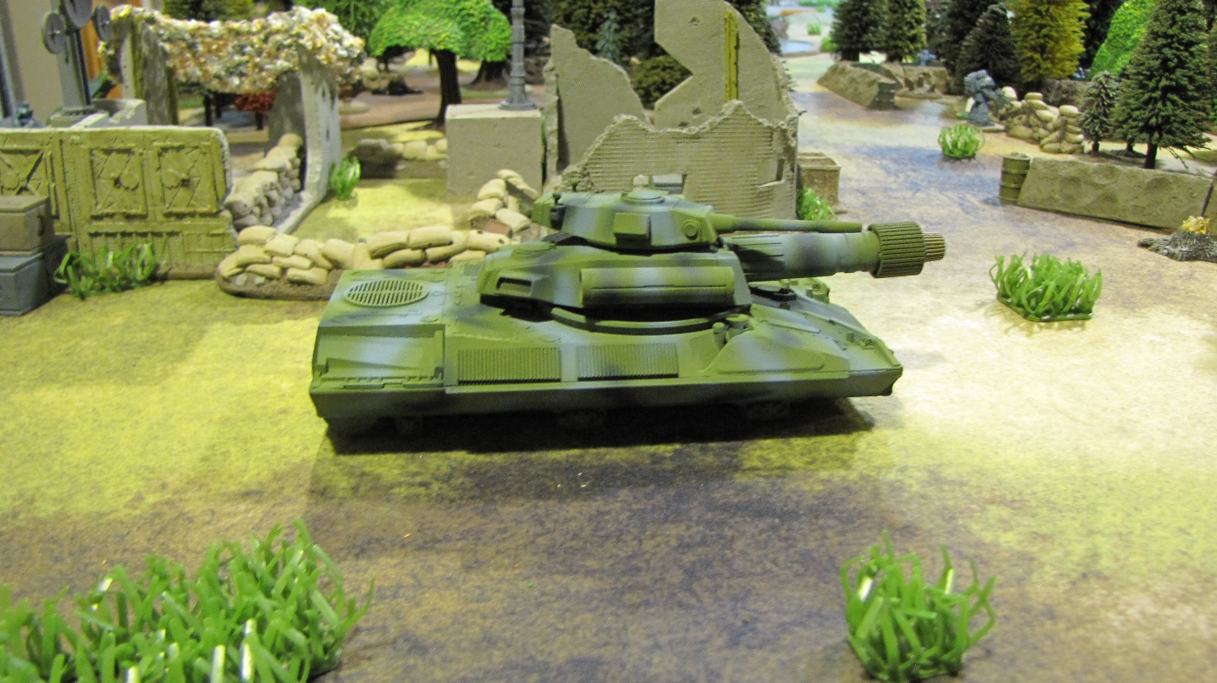
The Vanguard G-93 heavy grav tank positioned near the Gavilan HQ. The tank is armed with a heavy fusion cannon, a 75mm cannon and two missile pods with light attack missiles.

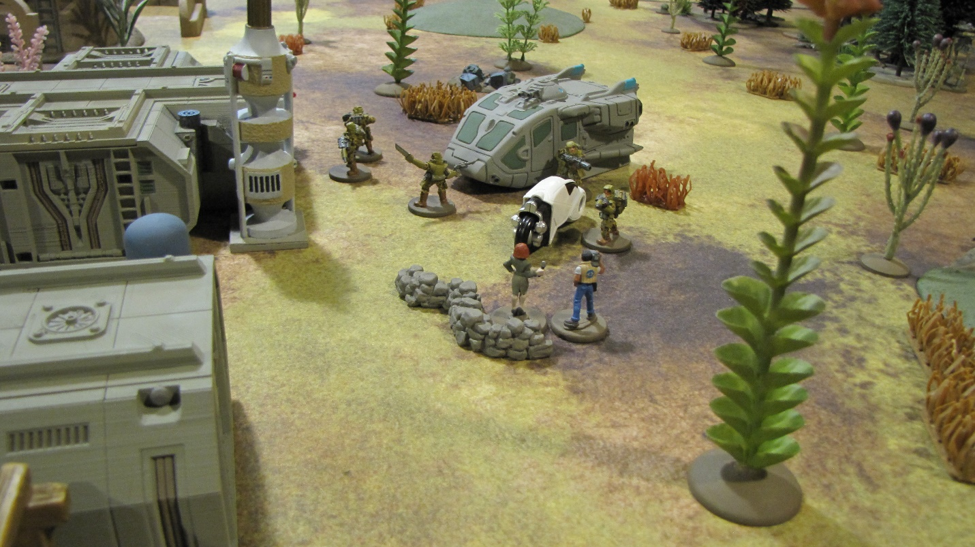
Too close for comfort! The CBS (Cosmic Broadcasting System) news team would quickly pull out as troopers of the 57th Omegan Rangers deploy from their Campaigner TO-1004 medium assault lander near the science station.

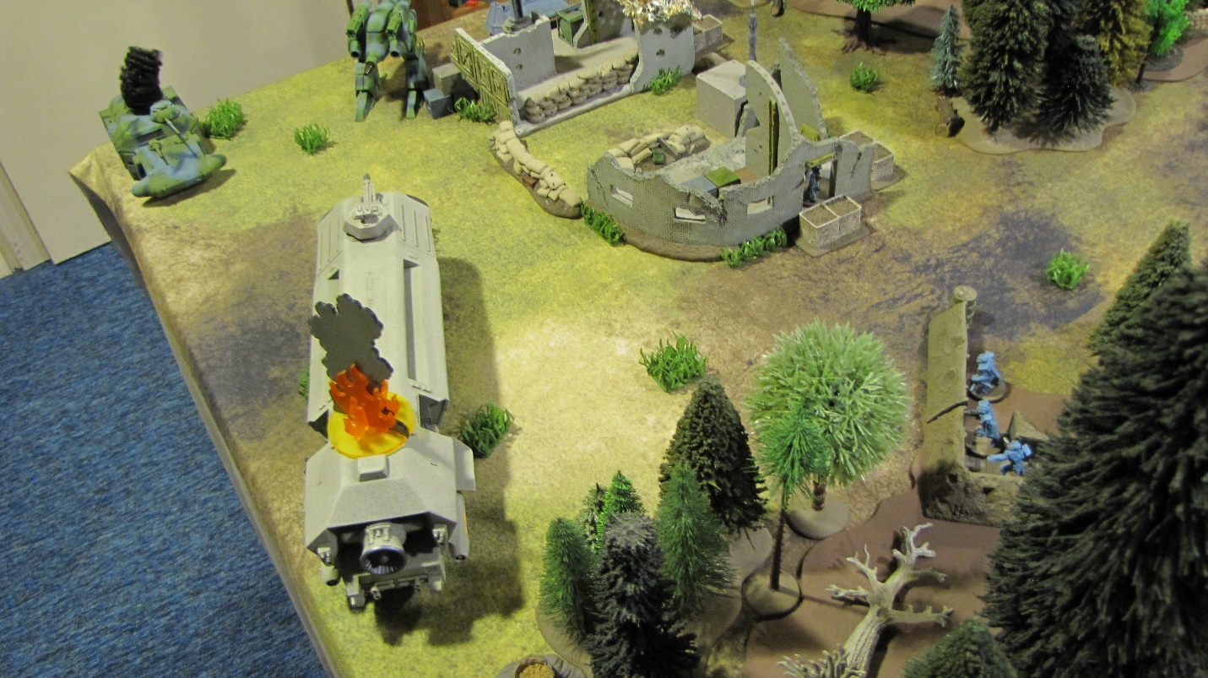
One hour into the battle the Zokar Constrictor GL-951 heavy assault lander completed its flanking move, entering the field near the enemy HQ. Its approach was anticipated and it was greeted with intense fire from an enemy Stalker G-216 medium battledrone and Corsair G-23 APC. The lander destroyed the APC, but shortly thereafter suffered explosive destruction, killing all but four of the ten troopers of the 50th Stormers it was transporting.

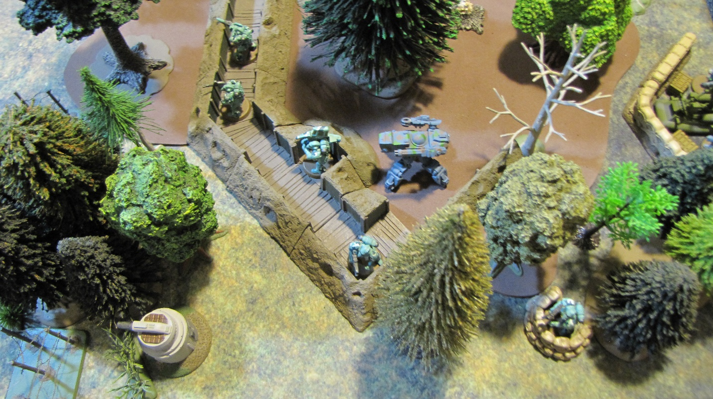
On the Gavilan left the Creeper light warbots have left the defenses to probe for oncoming enemy troops.

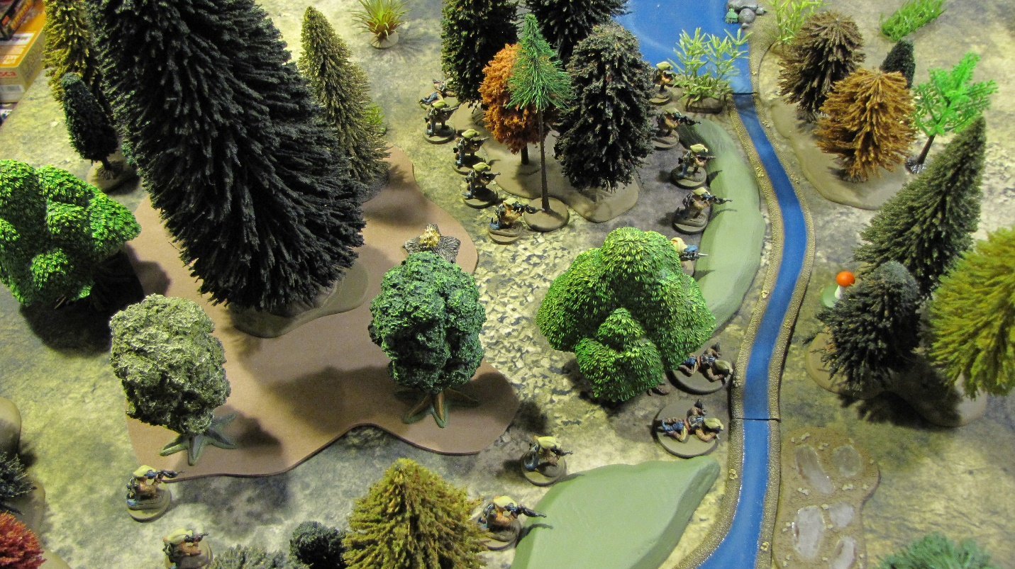
They would be met by two squads of the 32nd Saurid Strikers. Undetected at this point, the jetpack-equipped troopers advance quickly but carefully in tight formations, which they will abandon as soon as they come under fire.

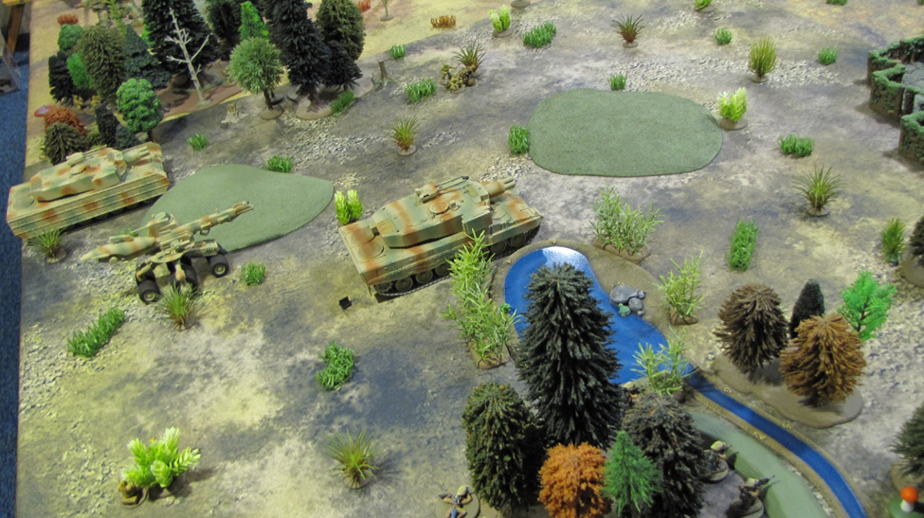
In the open ground to the left of the Saurid troopers two Tigershark Z-44 heavy tracked tanks and a Razorshark Z-233 heavy wheeled destroyer advance to provide support and attempt to gain fire superiority over the defender’s armored vehicles.

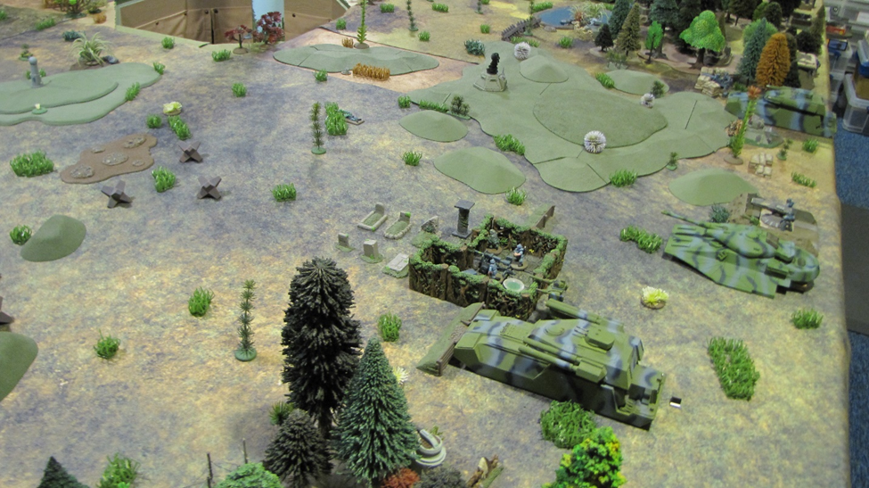
The Gavilan forces have two Conqueror G-31 heavy grav tanks (foreground and right rear) and a Flare G-205 heavy thruster tank to counter the Zokaran armored attack.

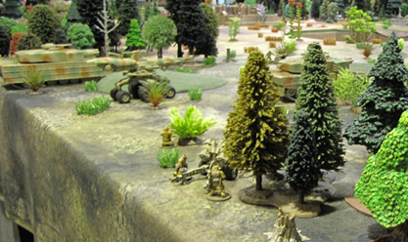
A Catapult Z-413 stands ready to provide indirect fire support with medium artillery rockets. The Catapult is produced under license from Hanaka by all stellar nations.

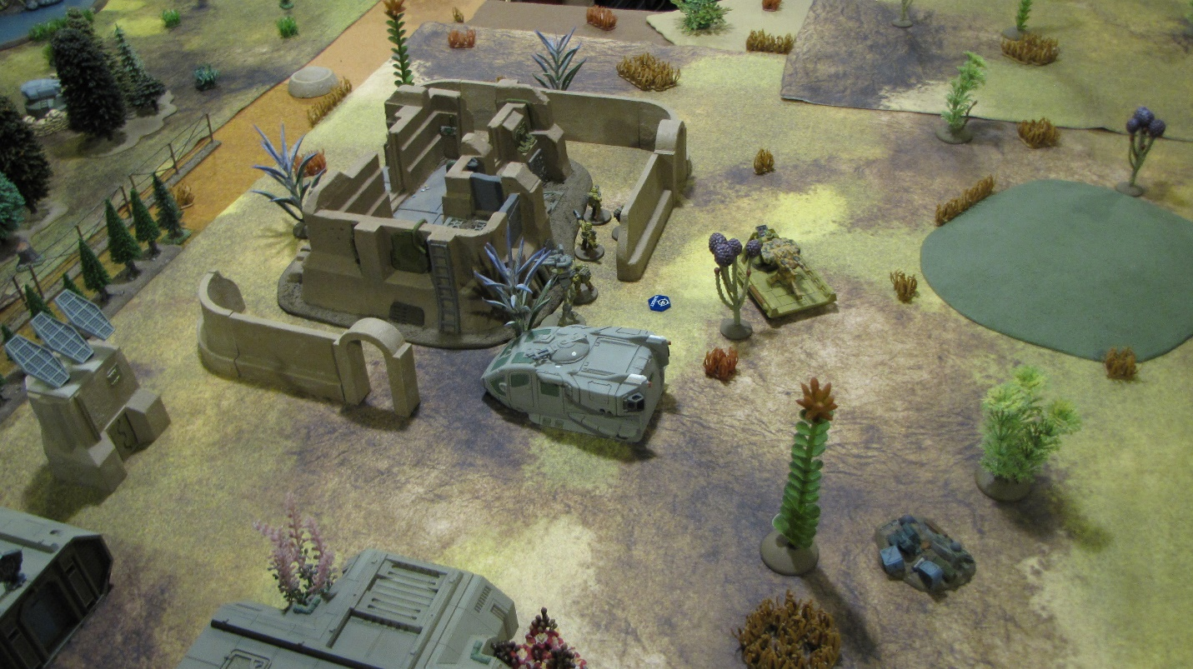
The Omegan Rangers seize control of the science station and the “old fort.” Gavilan probes by a small squad of elite 99th Felid Stalkers and a Brigand G-184 medium gundrone threaten the rangers briefly, but prove to be insufficient.

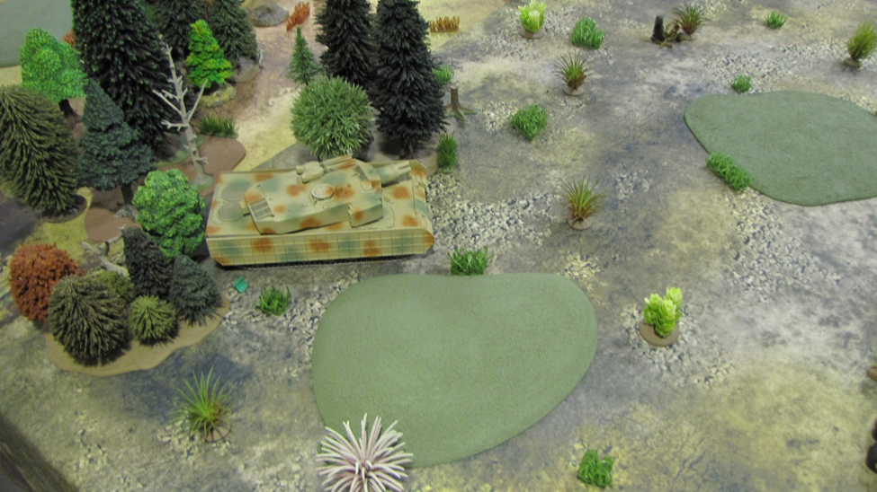
Hit by two air strikes, one Tigershark tank pulled back into the concealment provided by the trees until it could perform enough damage control to rejoin the fight. The air strikes knocked out all of its weapon and targeting systems.

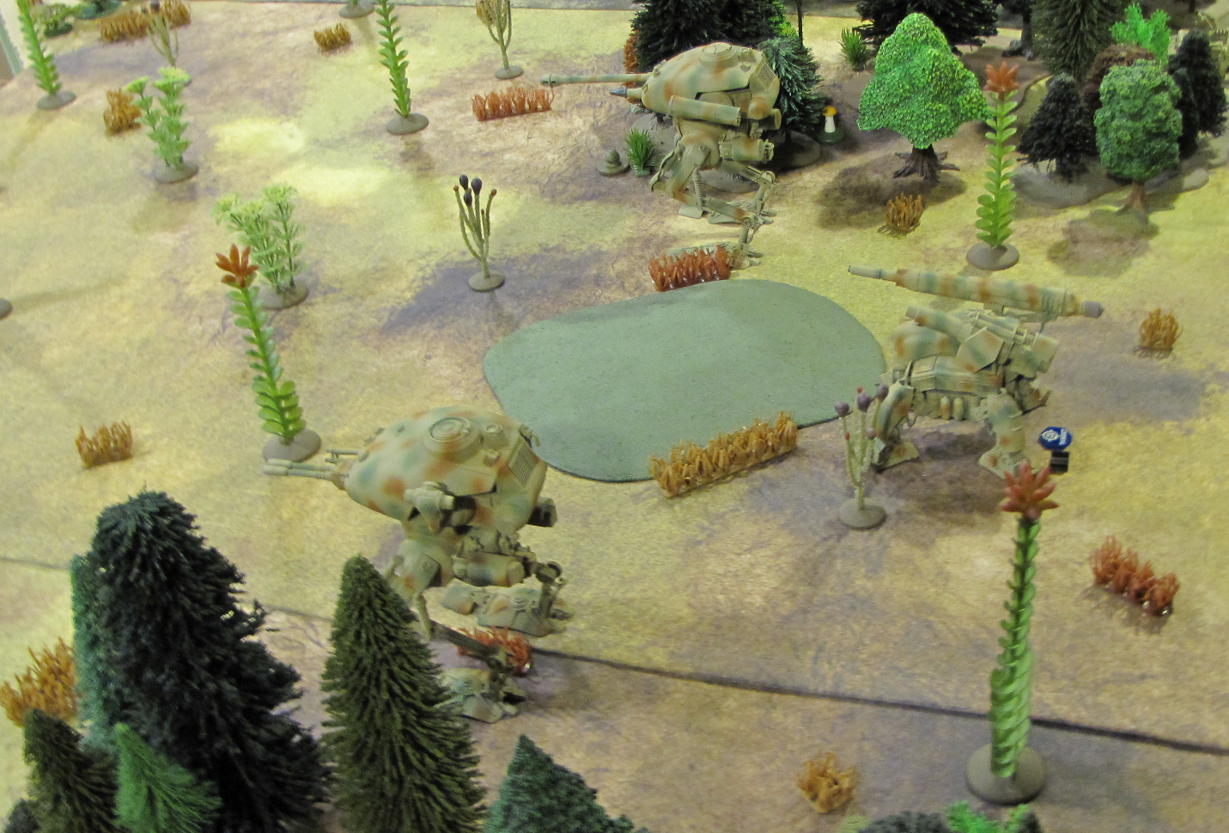
In the center, two Zokar Predator Z-46 heavy walker tanks advance, backed up by a Tarantula Z-247 medium walker tank with a 150mm howitzer and a medium disintegrator.

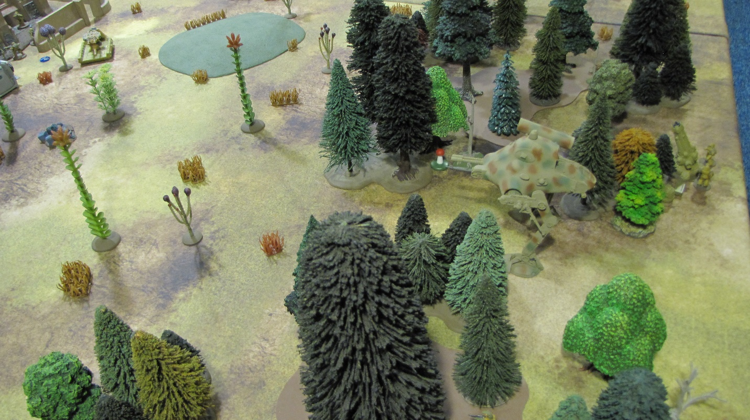
A Raptor Z-79b walker tank advances toward the science station.

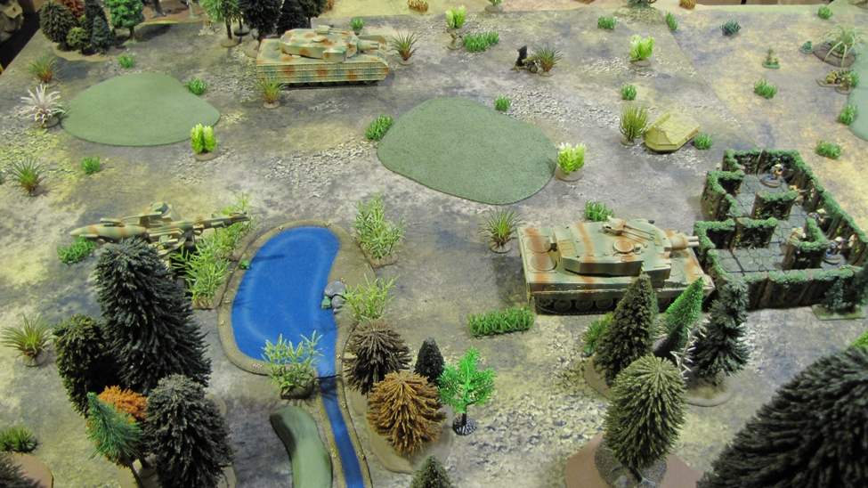
The long-range duel continues between the Zokaran and Gavilan heavy armored vehicles. The Zokarans have moved forward gaining more concealment and cover. During the half hour that Zokaran communications were not jammed they were able to set a number of target coordinates for their support artillery.

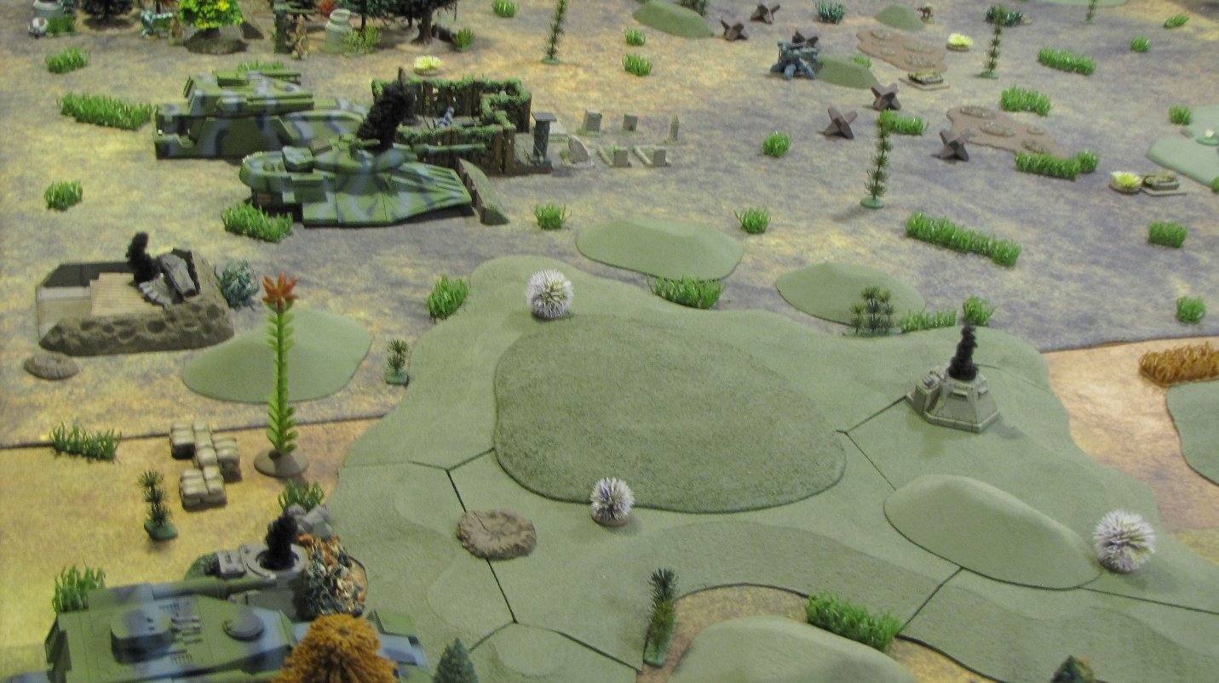
The Zokaran armor begins to assert itself as the Flare tank, the Sunfire weapon emplacement, the Firestorm artillery strongpoint and an Overseer observation cupola are destroyed. Black smoke marks the kills.

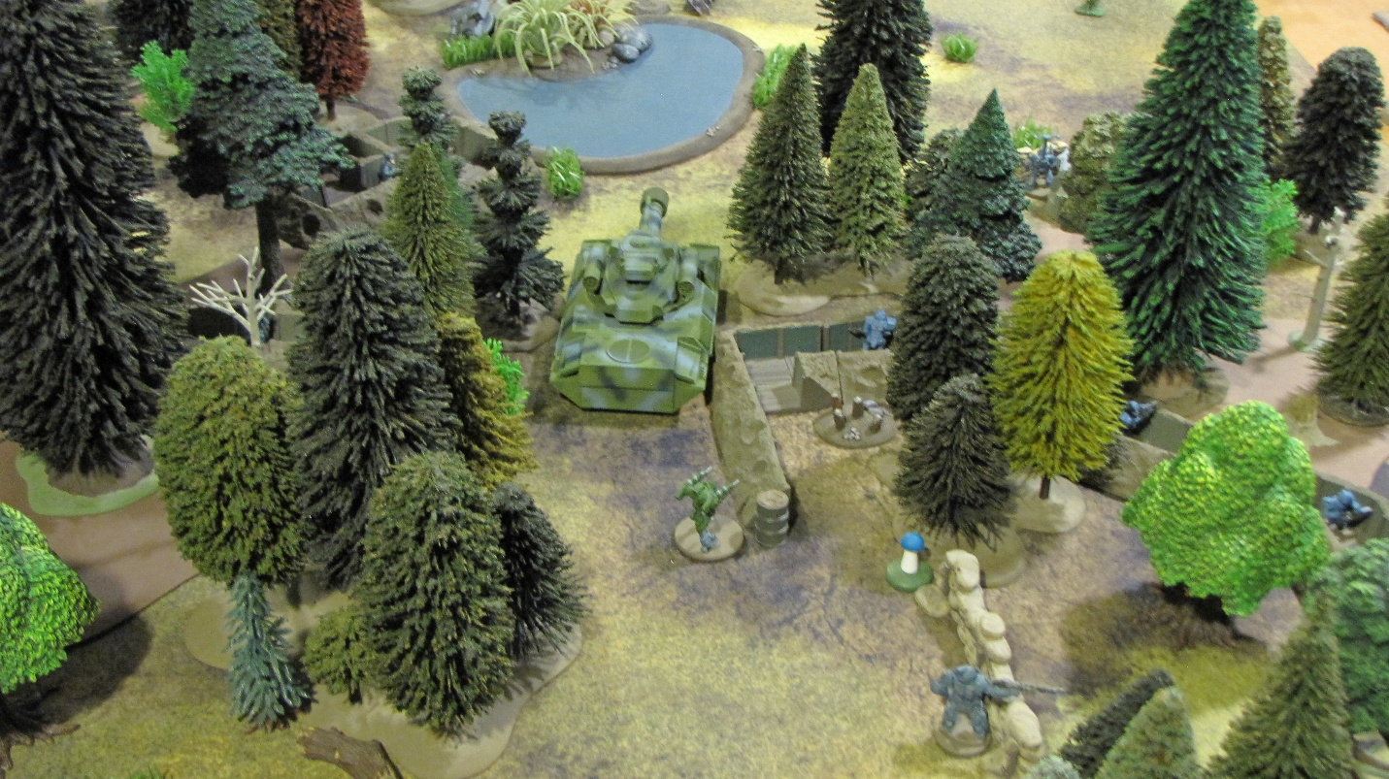
The Vanguard grav tank takes up a flanking position. Its fire would inhibit the enemy advance in the center.

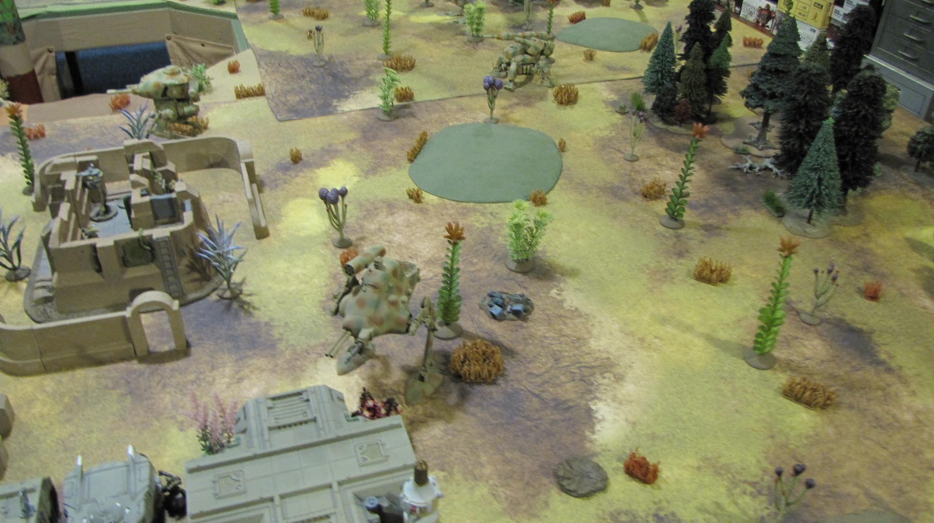
In control of the science station and “old fort,” the Zokaran forces would begin to whittle away the Gavilan forces entrenched in the woods to the west.

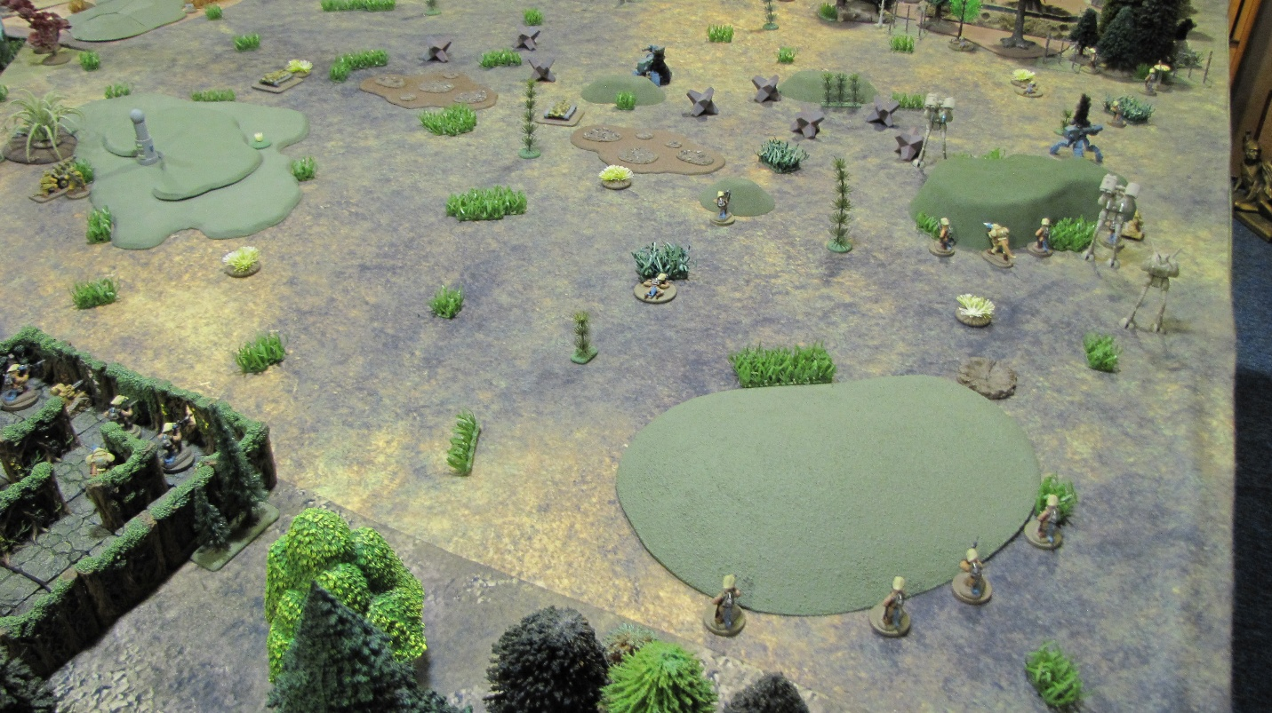
On the Zokaran right the troopers of the 32nd Saurid Stalkers press forward, supported by two Bearcat Z-119 medium wardrones (seen in the distance beside the small hill). Two Gavilan Creeper heavy warbots that pushed forward to disrupt the advance have been eliminated.

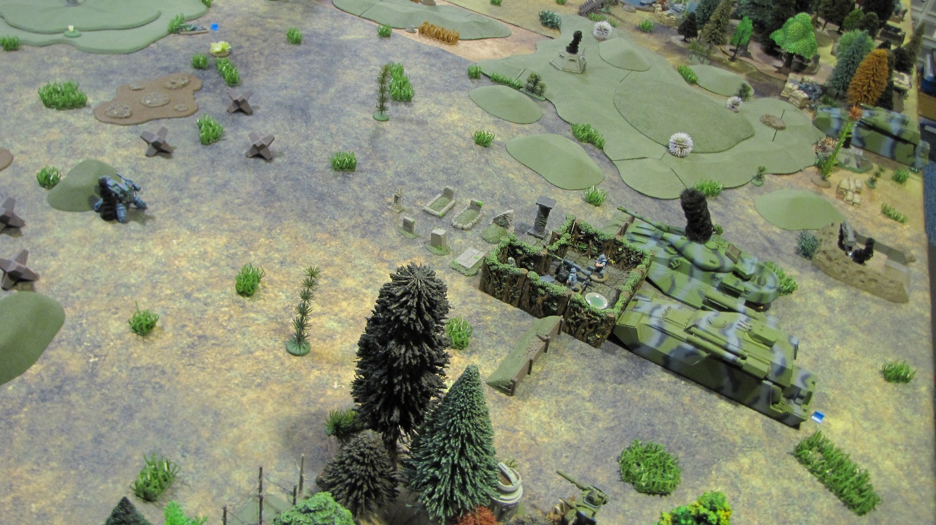
The damage to the Conqueror tank begins to mount as its stands alone against the mounting Zokaran pressure. With two weapon systems out and its targeting, damage control system and mobility reduced, the tank faces tough odds against surviving the battle.

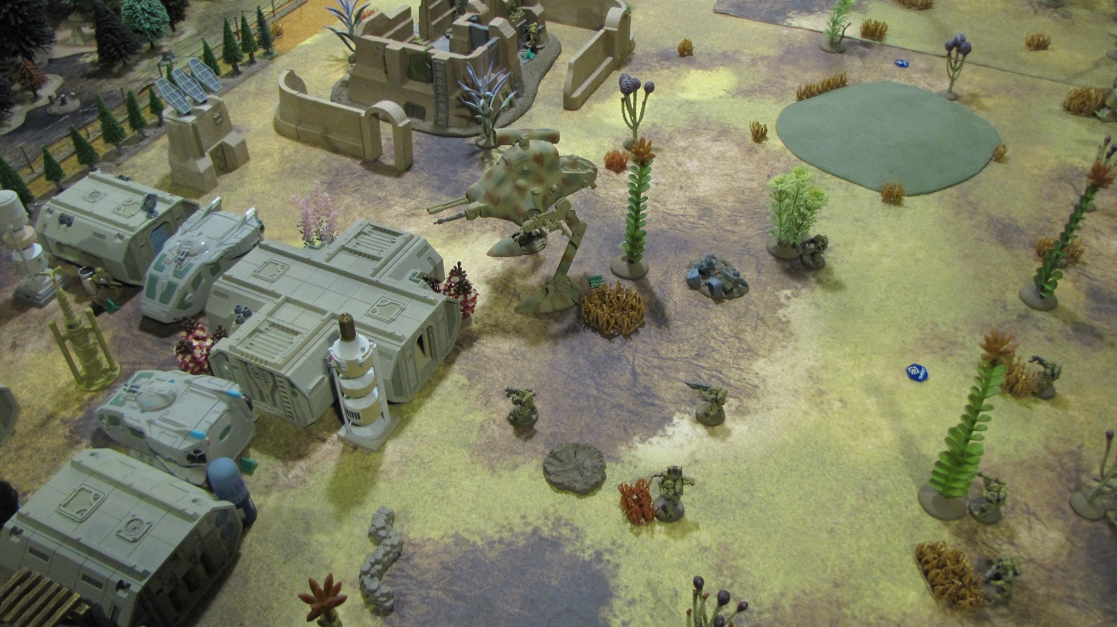
In addition to the Raptor walker tank, the Omegan Rangers begin to be reinforced by troopers of the 26th Stormers.

As stated previously, with losses mounting and no prospect of gaining an advantage that would turn the battle around, Gavilan Command ordered a retreat. The Zokaran victory meant that the Stellar Confederacy had secured a line along the prewar border, recapturing all territory lost to the initial Galactic Union offensive except in sector 7.5.

